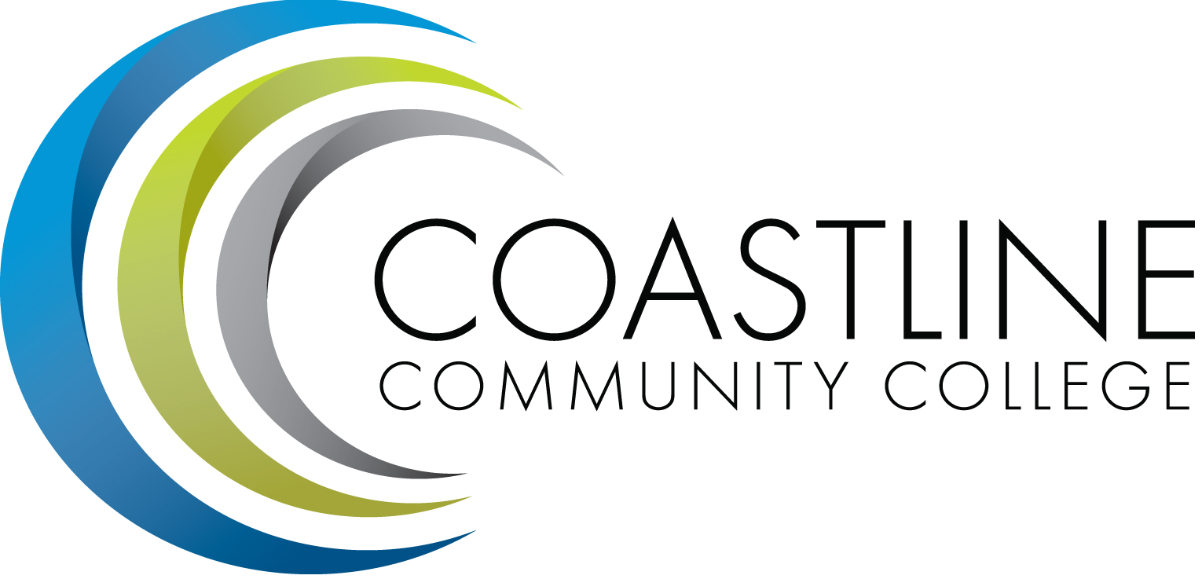
Technology Committee Agenda
09/20/2018, 3:00 p.m. – 5:00 p.m.
4th Floor Conference Room

Committee Mandate: This committee is responsible for the development and evaluation of a Technology Master Plan. The committee is also responsible for:
- The development of long and short range plans and priorities for CCC to facilitate the acquisition and deployment of technology
- The review, evaluation and recommendation regarding existing and emerging technologies that will enhance student learning and improve communication and computing technologies at Coastline

CALL TO ORDER
  - Welcome
  - Adoption of Agenda: 09/20/2018
  - Approval of Minutes: 05/17/2018

REPORTS

DISCUSSION
  - Technology Budget
  - Project Prioritization Process Review
  - Unified Communication
  - ChargeTech Phone Chargers
  - NCX Group Visits / Security
  - District schedule of planned outages
  - Standing Reports – Change in reporting

ACTION ITEMS
  - From May 17, 2018 Meeting
    - Technology Master Plan Review
    - GoPrint

STANDING REPORTS
  - District It Directors Meeting – Dave Thompson
  - District Technology Meeting – Dave Thompson
  - PIEAC
  - Academic Senate/FSC – Cheryl Chapman
  - Associated Student Government
  - Classified Senate
  - Canvas Work Group

ANNOUNCEMENTS
  - State funded Cloud based Library Services Platform – Elizabeth Horan

ADJOURNMENT

Next Meeting: October 18, 2018, 3:00-5:00 p.m., 4th Floor Conference Room
*Attachment has been emailed.
**Attachment available at meeting.

